Local Jenkins – Upload Code, test, and build if success

Step1: We need an extension! “Generic Webhook Trigger”:

Install that

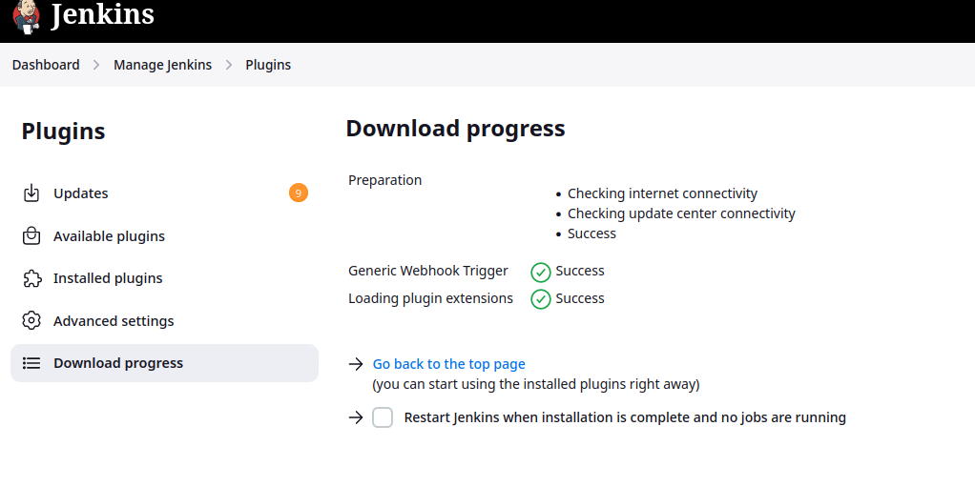

Step2: Prep work, start our local Docker Registry. This is built-in with the Docker command, so enjoy your server:

docker run -d -p 5000:5000 --name registry registry:2

Now it should be running (in a container?!) your own docker registry! Push an image to it:

docker pull alpine

